Super Monitoring

Magento 1.x version Module

**Description:-**

Super Monitoring is an external web application for monitoring website uptime and its basic functions.

This plugin integrates Super Monitoring interface into WordPress administration panel so you don't have to log in to supermonitoring.com separately to see your reports or update settings.

**Super Monitoring features:-**

- checking your website every minute

- detecting different kinds of failures

- using a worldwide network of monitoring stations to avoid false positives

- measuring response times

- content checking

- web form testing

- file integrity monitoring

- instant email & mobile text (SMS) alerts

- unlimited event history

- API.

**Installation: -**

1. Upload **app** Folder in to server root Folder

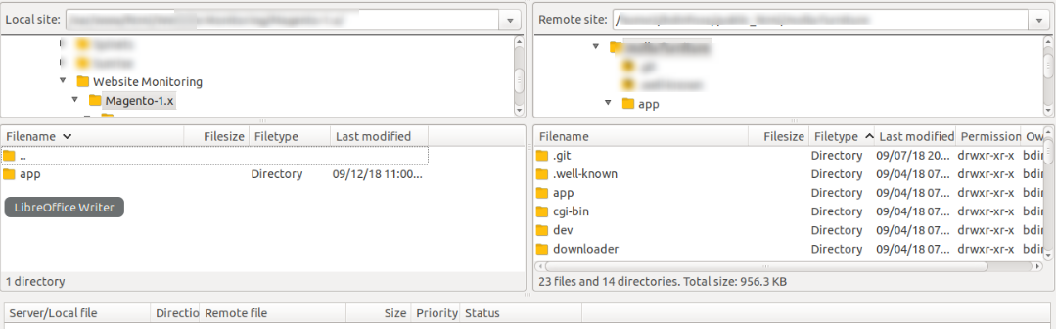

2. Refresh Cache .

**Configuration Guide :-**

**1.** Create an account in[**http://supermonitoring.co**](http://supermonitoring.com/)**m**

2. After login click on Your Account  
3. Copy token from

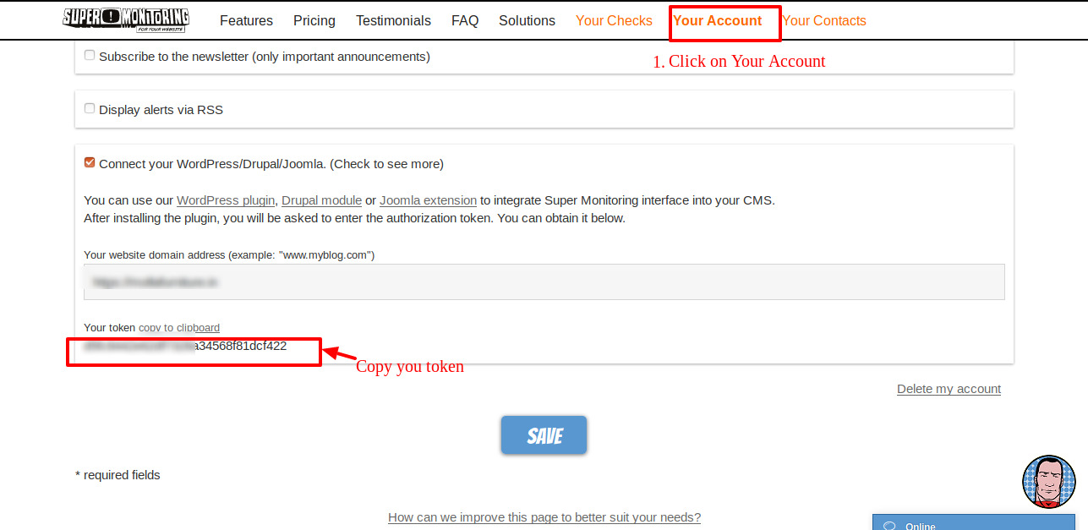

4. Put in Authorization token in system configuration

**If you seeing 404 not found error . Please logout and login again**

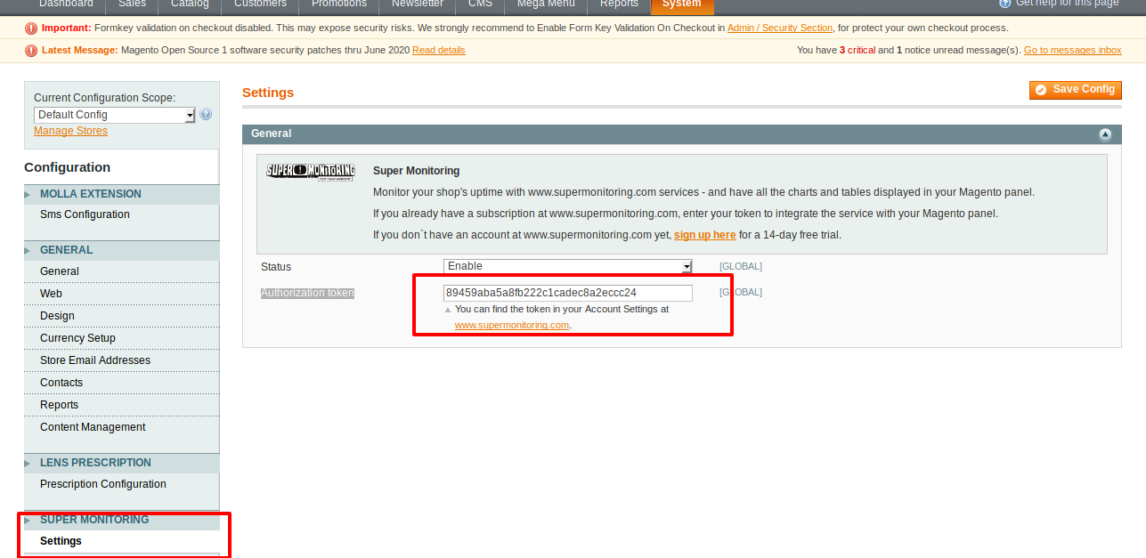

**Then Refresh cache.**

5. You can check Reports->Super Monitoring->Your checks

